Project Proposal

**Online Salon Management System for Salon Nimeshani**

Submitted By

A.S.V.S DE SILVA

SEU/IS/14/MIT/070



**Department of Management and Information Technology**

**Faculty of Management and Commerce**

**South Eastern University of Sri Lanka**

**2018**

Table Of Content

1. Introduction
   1. Scope
   2. Significance of the Project
2. Motivation towards
3. Problem Identification and drawbacks
4. Objectives with measurable outcomes
5. Key Process/Functions
6. Literature Review
   1. Advantages Of System
7. System development methods and methodology
   1. Requirement Analysis
   2. Design
   3. Implementation
   4. Testing and Development
8. Software , Hardware specification
9. Organization / Time schedule of the system development
10. Financial Budget for the system
    1. Breakdown of tasks and Durations
    2. Gantt chart with work schedule
11. References

1. Introduction

Salon Nimeshani situated at Wadduwa in kalutara. It is very famous in our area. Salon Nimeshani treatments are Ironing, Curls, Straightening , Relaxing , Re-Bonding, Facial Treatments, Bridal Beauty , Bridal dressing.

* Salon Name- Nimeshani
* Address- 298/A , Pothupitiya South, Wadduwa.
* Contact No- 0775850255
* E mail- Nimesha298@gmail.com

1.1 Scope

A **beauty salon** or **beauty parlor** (**beauty parlour**) (or sometimes **beauty shop**) is an establishment dealing with cosmetic treatments for men and women. There is a distinction between a beauty salon and a hair salon and although many small businesses do offer both sets of treatments In modern, beauty culture has taken a major step in our society. There are number of salons in each and every town in Sri Lanka. Those salons are not only located in urban areas but also in rural areas. Even though ladies are known for the interest on their beauty. So it was proven that hair and beauty salon is one of an important place for our modern society. This system make for women beauty.

Due to the number of salons, it has become a competition with each other to reach their customers and in modern there is a manual system to handle customer appointments. Today most of the people are busy with their day today works. So it is better to have an on line system for a salon to handle their customers and their requirements with an effective way.

On line web based salon management system is a better solution to solve above mentioned problem by using PHP as the programming language, MySQL for database purposes, CSS for the styling, HTML to create web pages and JQuery to simplify the client-side scripting of HTML.

1.2 Significance of the Project

Keeping tabs on all of your employees while making sure all of your customers are one hundred percent satisfied is a huge job in and of itself. However, throw your management duties and scheduling employees-on top of this and you may find yourself a bit overwhelmed. Online salon management software that will make handling all of your daily operations much simpler. With this salon management system, you will find that your business becomes a joy to run and not so much of a daily struggle. The features that come with salon software are comprehensive and include tools likes, appointment scheduling and many more, ensuring that your salon operates efficiently on a daily basis. If you have looked into another type of salon management software in the past, you may have been disappointed by the limited features included. However, with salon you will find that the comprehensive features of this software cover all aspects of running a successful beauty salon.

1. Motivation towards

The beauty salon has become an almost iconic figure in Western culture and Southeast Asian culture as well as in modern generation. There is a new trend in people to use hair and beauty salons. So generally they go to the salon and get their services.

In the 21st century, beauty and make up are like the wheels of a cart or the two sides of a coin. Women are beautiful in themselves; but a little make-up does help a lot and it keeps one to make the day better and happier. Every woman wants to be pretty whether she’s young or old so the beauty salon is the place to go [2].To get the services from the beauticians they have to go to the salon or sometimes they contact the beautician over the telephone. And also online salon management systems are very rare in our country.

There are some issues with the current way that it used to get services form the salons

* Customer has to go to the door step of the salon to make appointment and when there are many customers; customer has to wait until their chance comes.
* Customer does not aware of some useful information such as opening times, the nature of the services provided by the salon and also the prices or the price changes for them.
* Currently it used manual system to handle customer appointments and sometimes they may have not any historical details about the customers and the services provided for them.
* Currently it manually checks the availability of employees in the salon and manages the time for customer appointments.

By implementing “Online Salon Management System” it will prevent the issues regarding with customer appointments of a hair and beauty salon.

1. Problem Identification and drawbacks

* Requires internet access

Disadvantage of online salon management system are their reliance on internet connection. In order to book through an online salon management system customers will have to have access to the internet. This can be on their Smartphone, tablet, computer, laptop or any other internet-enabled devices.

* Can come at a cost

For all their positives , they do come at a monetary cost-don’t believe the promises of free online salon management system.

Some charge you per transaction, whilst others charge a flat monthly fee. So we will always know how much we are paying. Custom made online booking platforms will charge you a hefty lump sum up front.

1. Objectives with measurable outcomes

• Study about the major functions in a hair and beauty salon.

* Critical study of the technology that how the technology can be used to solve above mentioned problem.
* Design and develop a reliable and user friendly online salon management system.
* Use the proposed system to keep current customers happy by making effective time management for appointments and identifying customer requirements
* And also to manage the employee tasks, to enhance the number of customers, to manage the branches of the salon easily.
* Introduce a loyalty card system for frequent customers to make long term relationship with the salon.
* Create advance payment option for bridal dressing appointments.
* Send reminders to the customers regarding to their appointments.
* Prepare final documentation.

1. Key Process/Functions

mentioned earlier online web based salon management system is the proposed solution for above problem.PHP is the selected language to develop the system with the use of jQuery, HTML and CSS.

There are four types of users in the system exclude the system admin. .The four type of users include the branch managers and employees of the salon, customers and the visitors. The functions in the system are listed below.

1. User registration and management

* Register customers, branch managers and employees to the system.
* This is a system for ladies only salon and wish to register female customers only.
* Handle different dashboards for above users.

2. Administration functions

* Admin can enter basic functions to the system. (About cosmetics, services and their charges, special offers, opening times, branch details, consuming time for each and every service etc).
* Admin can manage the access privilege of the registered users.

3. Make an appointment

* Customer can make online appointments.
* Frequent customer can select her favorite employee while making appointment.
* Admin/Branch manager can make appointments in situation when customer does not make it online.
* Admin can view all the appointments.
* Brach manager can view the appointments for their own branch only.

4. Handle appointment

* Admin/Branch manager can accept/reject the appointments.
* Admin/Branch manager can distribute appointments among salon employees.
* Branch managers can distribute tasks among his/her branch employees only.

5. Employee Tasks

* An employee can view tasks assigned for him/her only.
* Employee can change the status of the assigned task (If the finished the task they can change the status as finished).

6. Uploading videos

* Admin can upload videos relating to the services in the salon.
* Customers can view those videos.
* Visitors can view only the trial videos.

7. Advance payments

* Customer can make online advance payment for bridal dressing appointments.
* This payment depends on the number of bride’s maids and flower girls.

8. Reminders

* Admin/Branch managers can send reminders to the customers via emails.

9. Customer loyalty card

* Introduce service packages for frequent customers who have made more than 5 appointments.
* There are there packages called Platinum, Gold and silver.
* These packages will include few services with discounts.
* This card will issue for limited time for each customer and include a unique number and expire date.
* This card will issue by the admin only.

10. Visitors to the system

* Visitors can view the services provided by the salon.
* If they are interested on them the can register to the system.

1. Literature Review

The traditional system of salon was manual and insecure because there was no any counting system of customers coming in the salon which creates sometimes major issues. The customer as well as the owner faces the problems. These early systems are dependent on paper pencil systems for billing purpose that means the records of bills of customer and the workers working in their salon are in written form. The records may get wrong due to anyone’s mistake. There is difficulty in maintaining records of all these tasks manually. Hence, proposed system is the best solution of avoiding all these problems. Salon manager are often responsible scheduling staff members, training new front desk workers. Since salon is a service sector, so the success of beauty salon depends on the satisfaction of customer. The business of salon is totally dependent on customer satisfaction.

6.1 Advantages of System

Advantage of online salon management system  is the only complete salon software application that will help you run salon to increased profits with features like appointment book salon software, salon client management software, salon inventory software, salon marketing software and salon accounting software.  This integrated solution is a complete answer to your needs because your front desk needs like appointment book, cash register functions and client management is integrated with inventory control, payroll, accounts payable and financials! Therefore you save time and money by not having to double enter information into two different systems. For instance all the commission that is automatically calculated for your employees will post over to the payroll program.

1. System development methods and methodology

The development of Online Salon Management System is based on waterfall model also known as software life cycle. The phases in waterfall model cascades from one to another. The waterfall model is an example of a plan driven process. In principle, planning and schedules of activities must be made before starting on them. There are five phases in waterfall model. The first phase is requirement definition followed by system and software design. The third phase is implementation and unit testing. The fourth phase is integration and system testing. The last phase is operation and maintenance.

**7.1 Requirement Analysis**

The aim was to develop online software for salon industry and deliver it based on SaaS model to different saloon owners. Subscribing to this software the salon owner can have their own online salon store and provide a new way to their business. The software was required to provide convenience to saloon customers (service appointment hirer) to book online appointments using a user friendly calendar. The software should suggest a nearest store location. The website is having mainly four types of users such as: Salon owner, Salon services provider person (Woman salon services provider under each salon),Customers (Salon services hirer) and Website super administrator .Client wanted to provide more comprehensive features within robust website architecture along with more user- friendly and efficient accessibility to the application users. Website was required to have social site integration options within Twitter and Face book .The client wanted to implement features like inventory management, managing payroll, call-to-confirm appointments and sending out reminders for its business users (saloon owners/ service providers) besides creating their business website and social networks.

Client wanted to develop this software product through various technology platforms such as Web-based development, Mobile Platform development (iPhone / iPad / iTouch / Android) & Face book Website Development

**7.2 Design**

For proposed system researcher will be mainly used to Entity Relationship Diagram. Entity Relationship Diagram will help to represent the all entities relate to this system and the each relationship between those entities. This process will enable the analyst to understand database structure so that data can be stored and retrieved in a most efficient manner. Further, researcher will be used the Use case diagram for give the conceptual view of the proposed system.

**7.3 Implementation**

In order to develop the front-end of the system, Sublime editor , Photoshop, Illustrator –Image editing will be used. The front-end will be web based application. In order to develop the front-end of the system, XAMPP server will be used. For Schedule development Microsoft Project 2010 will be used.

**7.4 Testing and Deployment**

Researcher will develop proposed system as separate modules. For it researcher will use Sublime editor , Photoshop, Illustrator –Image editing. XAMPP server will use to develop the database for proposed system.

Researcher will test proposed system as unit by unit and finally will be tested as an entire system as a one unit. Under the testing researcher will use the White box testing mainly. Because it test of the structural internals of the codes.

1. Software , Hardware specification

**Software requirements**

* Design and developing techniques – PHP, jQuery, CSS.
* XAMPP server
* Sublime editor
* Ms project – Gantt chart
* Photoshop, Illustrator –Image editing
* Star UML/Dia – Draw diagrams
* Mozilla firefox, Chrome – web browsers

**Hardware requirements**

* CPU – Intel Platinum (2 GHz or higher)
* OS - Windows
* Memory – 1GB or higher
* Hard disk – 40 GB or higher

1. Financial Budget for the System

|  |  |
| --- | --- |
| **Description** | **Amount** |
| Hardware purchase (Computer, Printer, etc.) | Rs. 80400.00 |
| Software purchase (exclude free editions of software packages) | Rs. 60650.00 |
| Printing & Binding of Report | Rs. 6300.00 |
| Miscellaneous | Rs. 5800.00 |
| **Total Amount:** | **Rs. 153,150.00** |

10. Organization/Time schedule of the system development

10.1 Breakdown of tasks and Durations

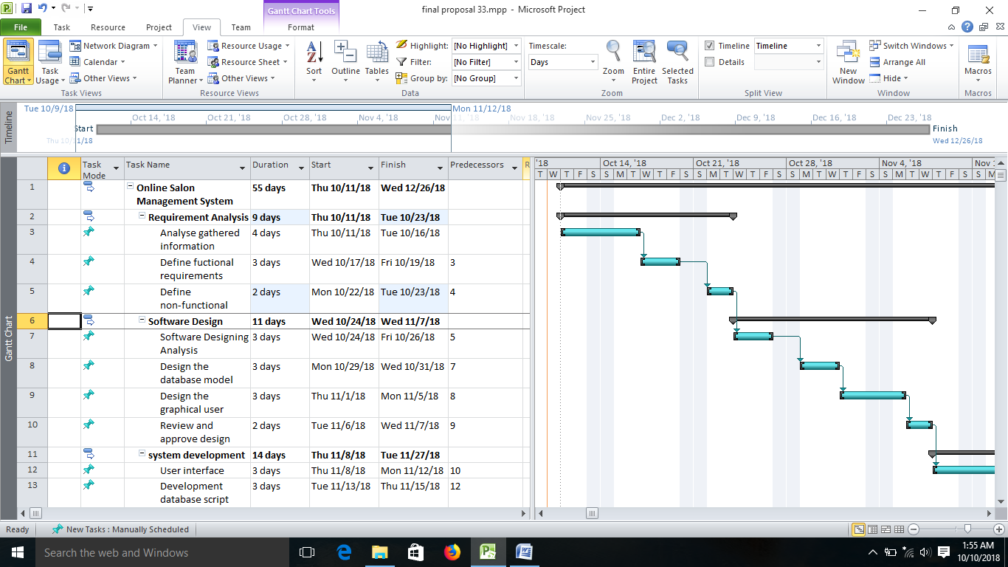

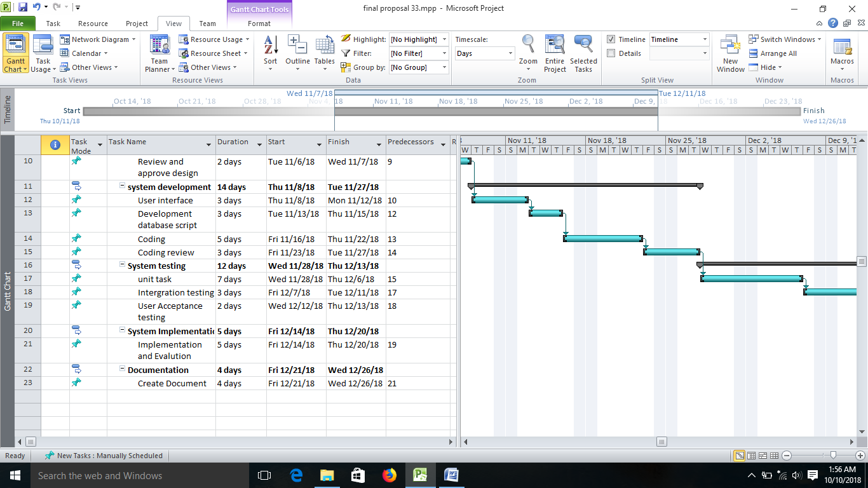

10.2 Gantt chart with work schedule

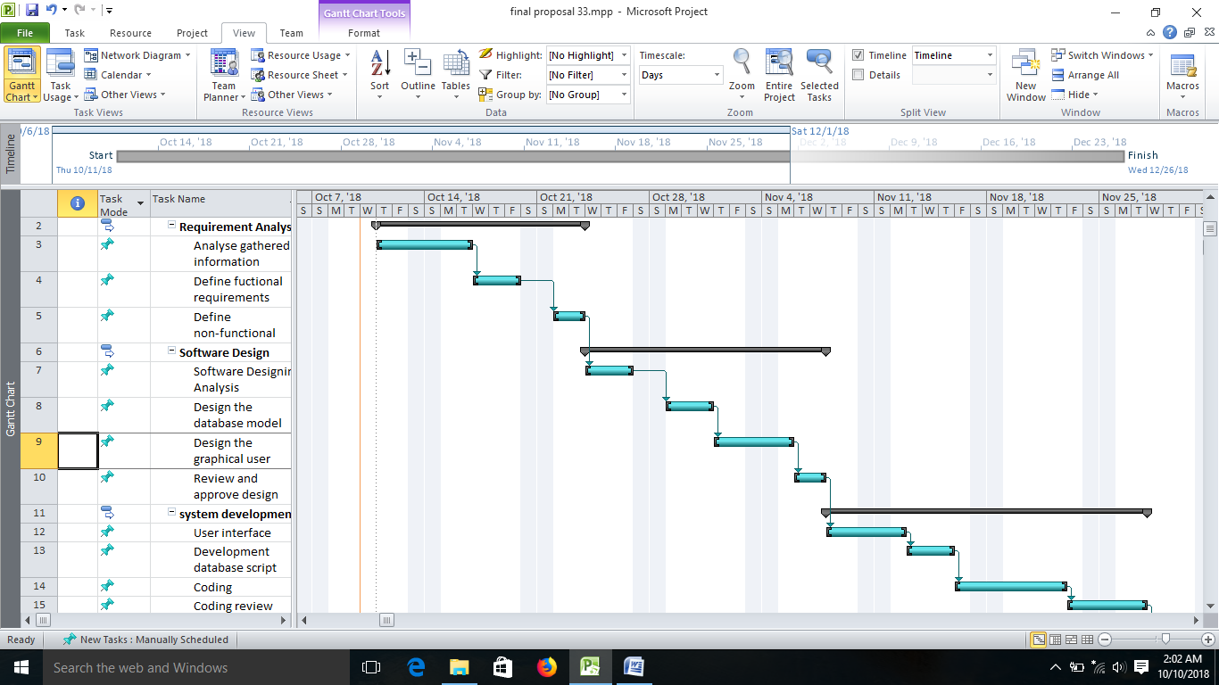

11. **References**

[1] “Beauty salon”. Internet: http://en.wikipedia.org/wiki/Beauty_salon, Mar.5, 2015 [Mar. 18, 2015]

[2] Cheque.”Introduction on Beauty Salon Business”. Internet:http://www.studymode.com/essays/Introduction-On-Beauty-Salon-Business- 200796.html, Apr. 12, 2009[Mar. 18, 2015

* 1. Timeline and work calendar

1. Conclusion